DevOps

Cloud Formation 2

Overview 2

CloudFormation Template Components 4

# Cloud Formation

## Overview

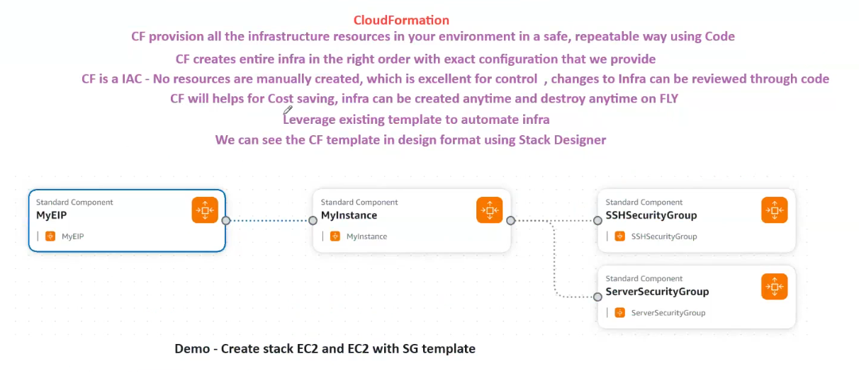

**Definition:**

CloudFormation (CF) is an AWS service that allows for the provisioning and management of infrastructure resources in a safe, repeatable way using code.

**Key Features:**

1. **Infrastructure as Code (IAC)**:
   * CF templates are written as code, enabling automation and version control.
   * No manual creation of resources, ensuring consistency and repeatability.
2. **Automated Infrastructure Provisioning:**
   * CF builds the entire infrastructure in the correct order, adhering to the configuration specified in the template.
   * This approach eliminates errors and ensures efficient resource management.
3. **Change Management and Control:**
   * Since resources are provisioned through code, any changes can be easily tracked and reviewed.
   * This makes it ideal for maintaining compliance and auditing infrastructure changes.
4. **Cost Savings and Efficiency:**
   * Resources can be created and destroyed on demand.
   * Minimizes costs by eliminating unnecessary resource usage.
5. **Infrastructure Flexibility:**
   * Templates can be reused to automate different infrastructure setups.
   * Supports leveraging existing templates for quicker deployments.
6. **Visual Representation:**
   * The CF template can be visualized in a design format using **Stack Designer**, allowing easy inspection and modification.

**Example Scenario: Creating an EC2 Instance with Security Groups**

**Objective:**

To create a CloudFormation stack that provisions:

1. An EC2 instance (MyInstance).
2. An Elastic IP (MyEIP).
3. Two Security Groups:
   * SSH Security Group (SSHSecurityGroup).
   * Server Security Group (ServerSecurityGroup).

**Components:**

1. **Elastic IP (MyEIP)**:
   * Allocates a static IP address to the instance.
   * Ensures that the instance has a consistent IP address.
2. **EC2 Instance (MyInstance)**:
   * The main compute resource to host applications or services.
   * Attached to the allocated Elastic IP (MyEIP).
3. **SSH Security Group (SSHSecurityGroup)**:
   * Allows SSH access (typically on port 22).
   * Ensures secure remote management.
4. **Server Security Group (ServerSecurityGroup)**:
   * Configures server-specific inbound/outbound traffic rules.
   * Enhances security by segregating application traffic.

**Demonstration:**

The demonstration in the image focuses on:

* Creating a CloudFormation stack with an EC2 instance and associated security groups using a template.
* Showcasing the automated creation and management of the infrastructure through CF templates.

## CloudFormation Template Components

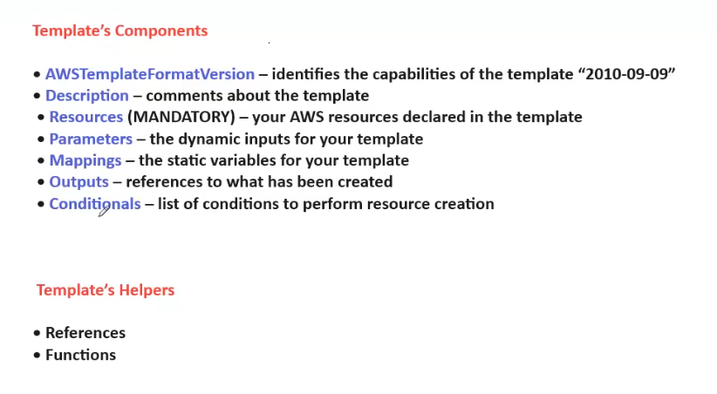

**AWS CloudFormation Template Components**

CloudFormation templates are declarative JSON or YAML files used to define AWS infrastructure as code (IAC). The templates consist of several key components, each serving a specific purpose.

**1. Template Components**

1. **AWSTemplateFormatVersion:**
   * Identifies the version of the CloudFormation template format.
   * Current version: **"2010-09-09"**.
   * Helps AWS determine how to interpret the template.
2. **Description:**
   * A textual comment section to describe the purpose or details of the template.
   * Improves template readability and maintainability.
3. **Resources (MANDATORY):**
   * The most crucial section of any CloudFormation template.
   * Defines all the AWS resources to be created, such as EC2 instances, S3 buckets, security groups, etc.
   * Every template must have at least one resource defined.
4. **Parameters:**
   * Allow the template to accept user inputs during stack creation.
   * Useful for making templates flexible and customizable.
   * Example: Instance type, AMI ID, or any other configuration parameter.
5. **Mappings:**
   * Define static variables that can be referenced within the template.
   * Useful for region-specific values, such as AMI IDs or instance types.
6. **Outputs:**
   * Define values that are returned after the stack creation or update.
   * Typically used to provide essential information, such as the public IP of an EC2 instance or resource ARNs.
7. **Conditionals:**
   * Specify conditions that determine whether certain resources are created or configured.
   * Enable resource creation based on environmental variables or parameter values.

**2. Template Helpers**

1. **References:**
   * Allow you to reference parameters, resources, or other values within the template.
   * Examples: Ref, Fn::GetAtt, etc.
2. **Functions:**
   * Allow template manipulation and dynamic configuration.
   * Include intrinsic functions like Fn::Join, Fn::Sub, Fn::If, Fn::Equals, and more.